Curved-Line Generator

Definition
# Source: AI Source: Provided by: [Data Path: Persons Table -> ID Column: 1, Name_En Column: Motasem Essam] -> From: [ChatGPT] on [7/25/2026]
A Curved-Line Generator (also called a Curved Generatrix or Generating Curve) is a curved geometric line that moves according to a specified geometric rule to generate a surface in three-dimensional space.
Unlike a straight-line generator, which uses a straight line, a curved-line generator uses a curved element such as a circle, semicircle, ellipse, parabola, or hyperbola.
When a curved-line generator rotates around a fixed axis, it produces a Surface of Revolution. Depending on the generating curve and its position relative to the axis, the resulting surface may be a sphere, torus, ellipsoid of revolution, paraboloid of revolution, or hyperboloid of revolution.

Geometric Representation
# Source: AI Source: Provided by: [Data Path: Persons Table -> ID Column: 1, Name_En Column: Motasem Essam] -> From: [ChatGPT] on [7/25/2026]
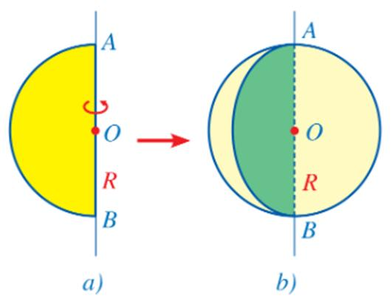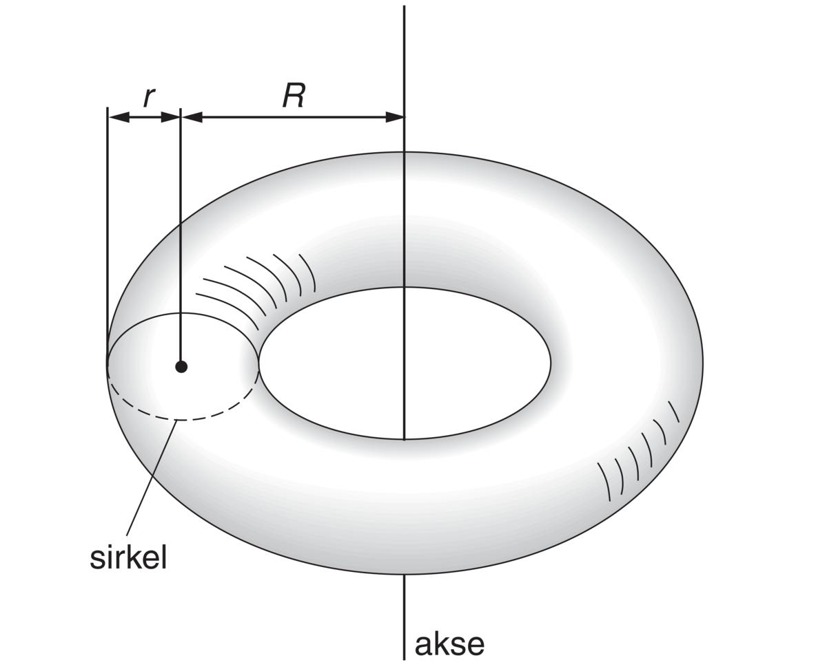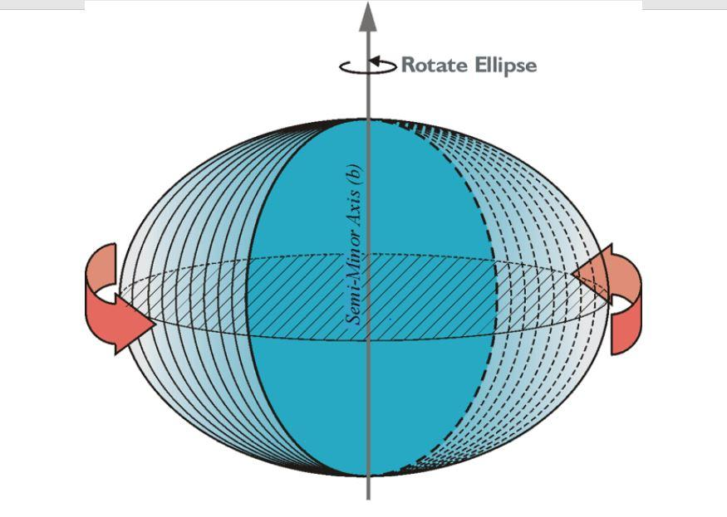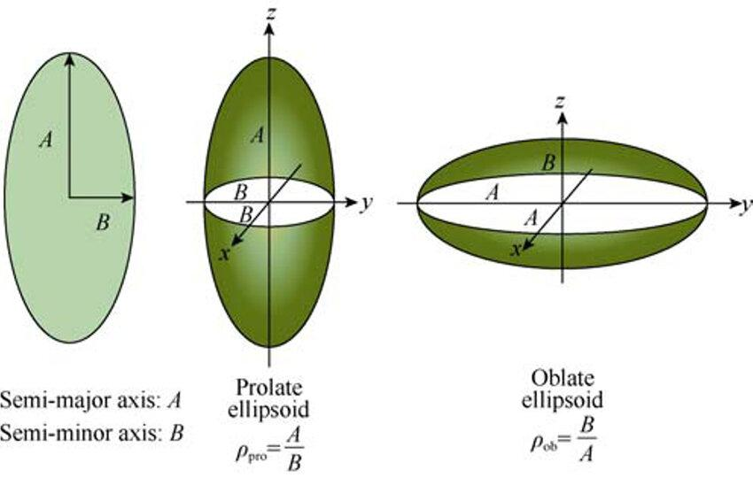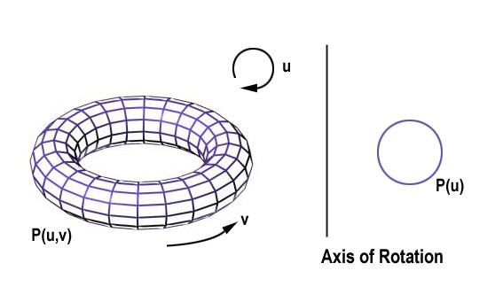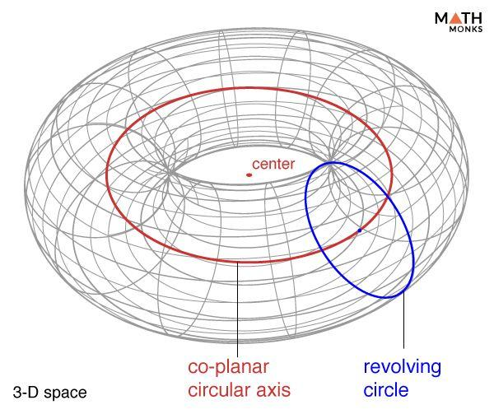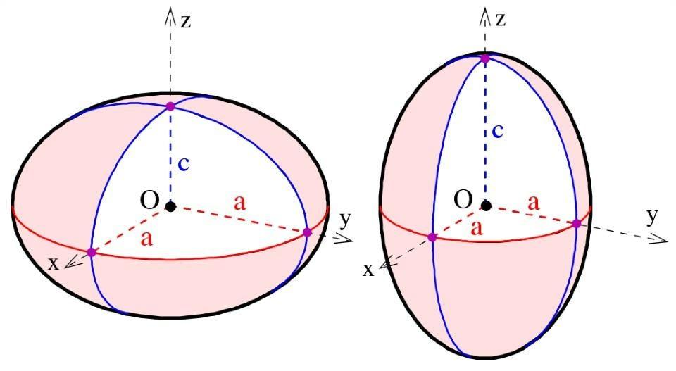

Geometric Structure
# Source: AI Source: Provided by: [Data Path: Persons Table -> ID Column: 1, Name_En Column: Motasem Essam] -> From: [ChatGPT] on [7/25/2026]
A curved-line generator has the following characteristics:
- Curved Form: The generating element is a curved line rather than a straight line.
- Continuous Motion: It moves or rotates according to a defined geometric rule.
- Generating Curve: Its shape determines important characteristics of the resulting surface.
- Axis Relationship: It may rotate around a fixed axis or follow another spatial path.
- Surface Formation: Its successive positions form a continuous surface.
- Geometric Variation: Different curves and axis positions can produce different surfaces.

Fundamental Elements
# Source: AI Source: Provided by: [Data Path: Persons Table -> ID Column: 1, Name_En Column: Motasem Essam] -> From: [ChatGPT] on [7/25/2026]
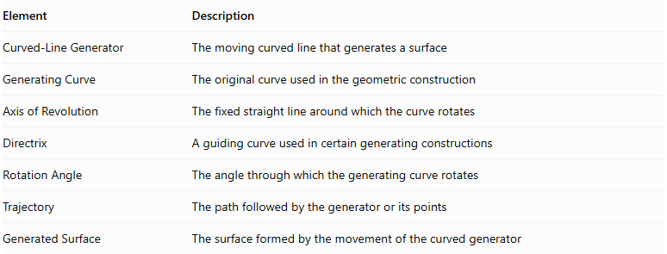
Element | Description
Curved-Line Generator | The moving curved line that generates a surface
Generating Curve | The original curve used in the geometric construction
Axis of Revolution | The fixed straight line around which the curve rotates
Directrix | A guiding curve used in certain generating constructions
Rotation Angle | The angle through which the generating curve rotates
Trajectory | The path followed by the generator or its points
Generated Surface | The surface formed by the movement of the curved generator

Types of Curved-Line Generators

Circular-Arc Generator
# Source: AI Source: Provided by: [Data Path: Persons Table -> ID Column: 1, Name_En Column: Motasem Essam] -> From: [ChatGPT] on [7/25/2026]
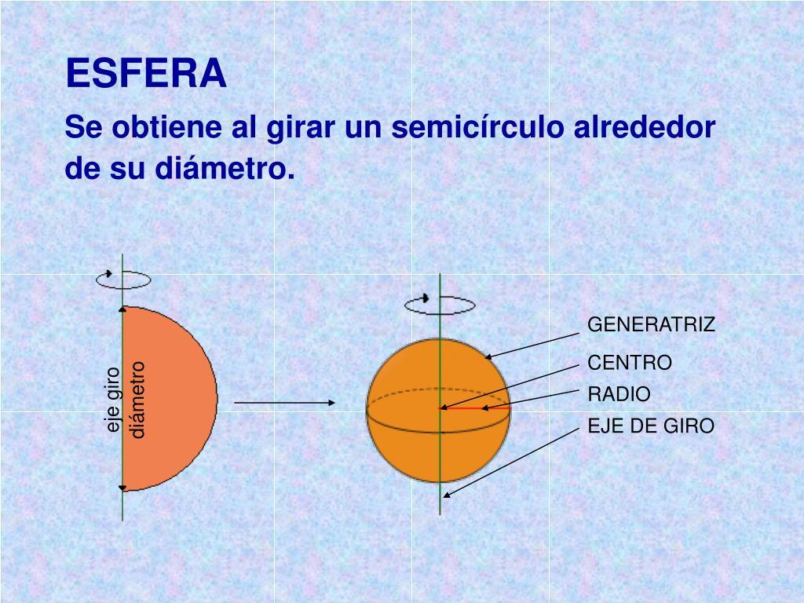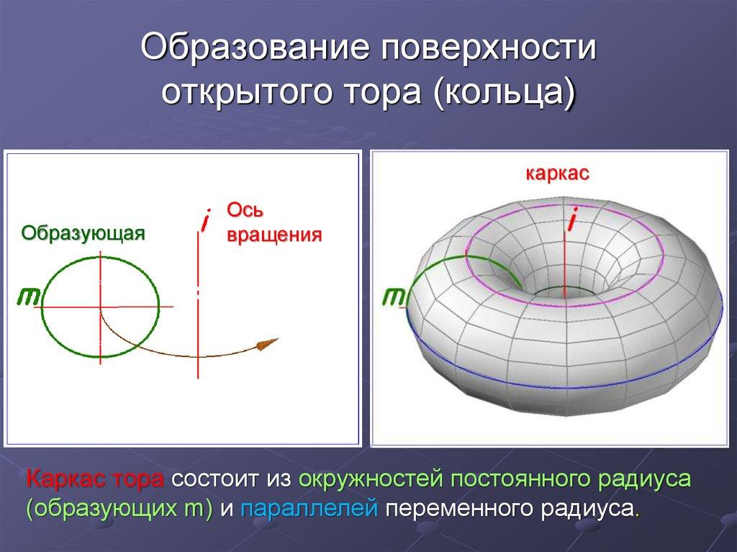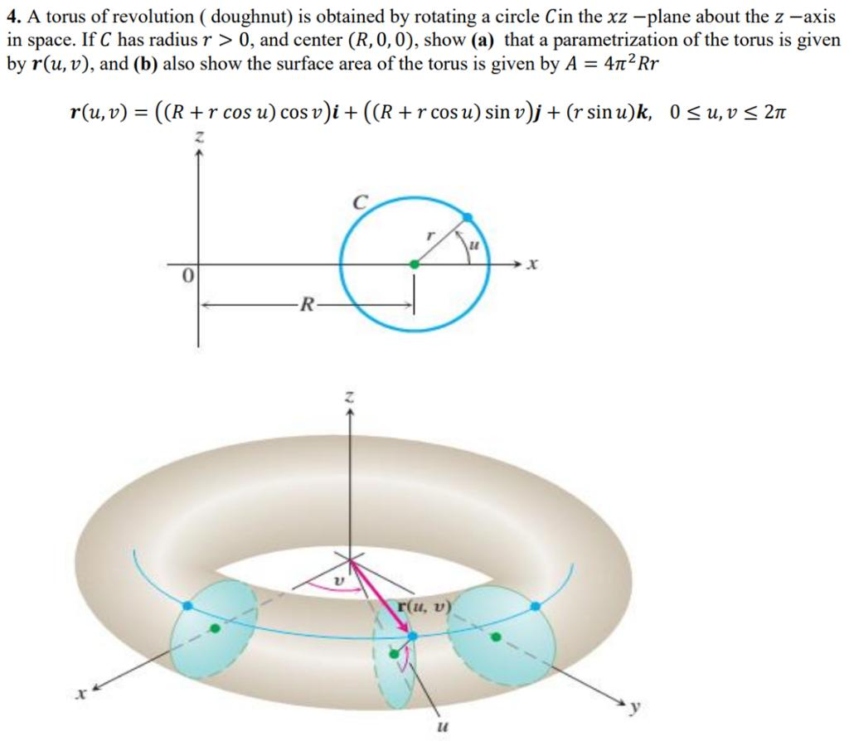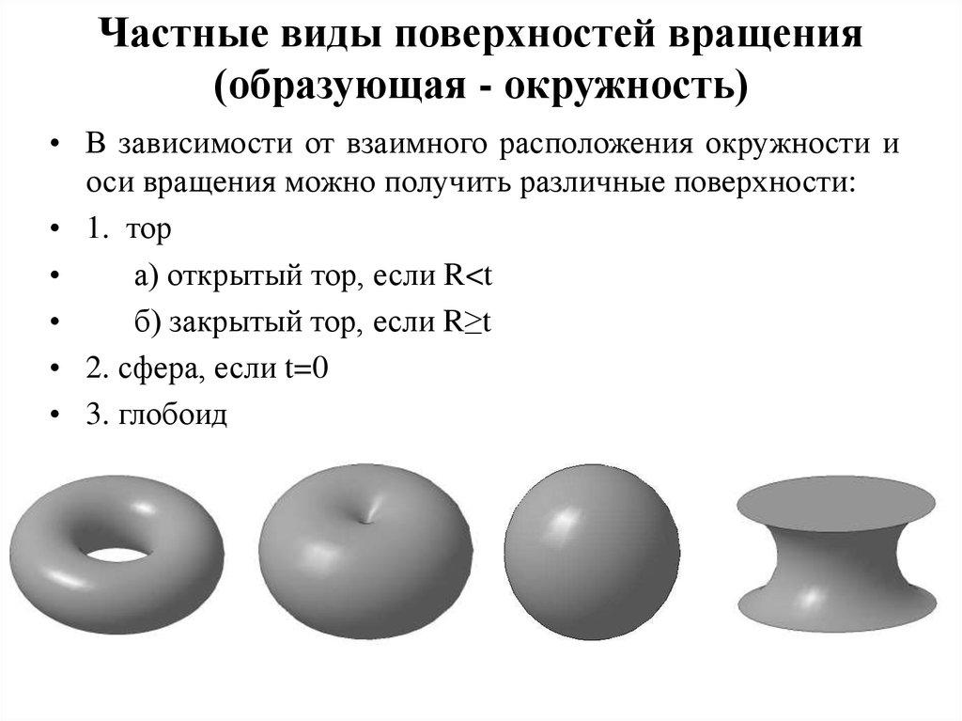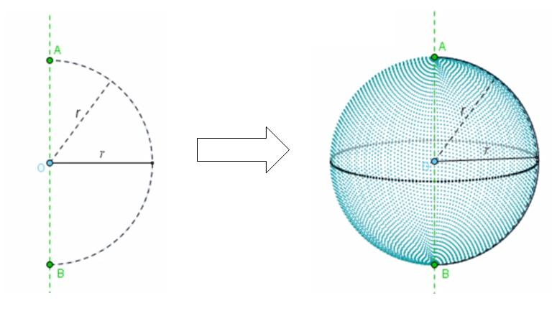
A Circular-Arc Generator is a curved-line generator whose shape is part of a circle.
Depending on its position and rotation axis, it can generate different curved surfaces.
Examples:
- Spherical Generator: A semicircular arc rotates around its diameter to generate a spherical surface.
- Torus Generator: A circular arc rotates around an external coplanar axis to generate a toroidal surface.
- Spherical Segment Generator: A suitable portion of a circular arc rotates around an axis to generate part of a spherical surface.

Semicircular-Arc Generator
# Source: AI Source: Provided by: [Data Path: Persons Table -> ID Column: 1, Name_En Column: Motasem Essam] -> From: [ChatGPT] on [7/25/2026]
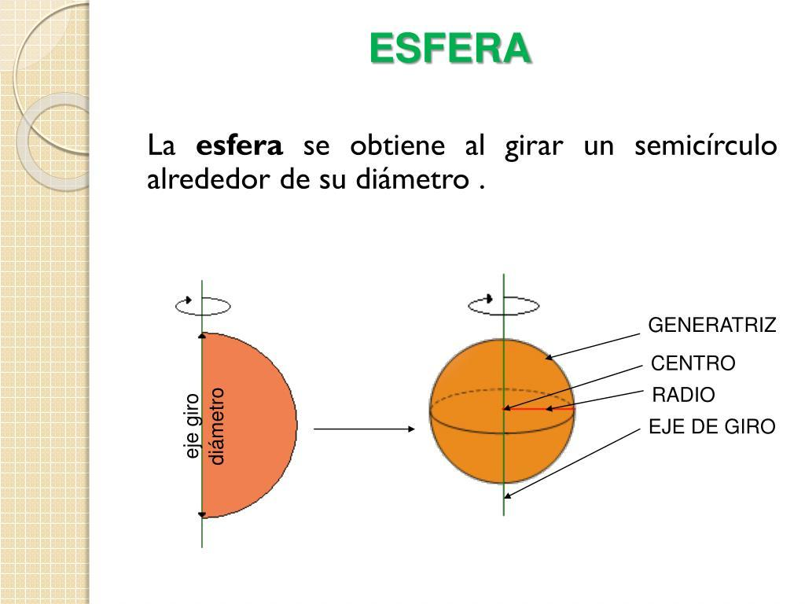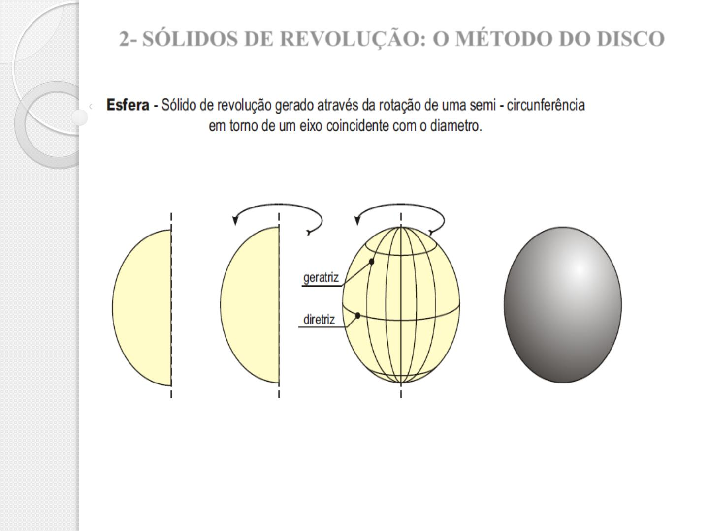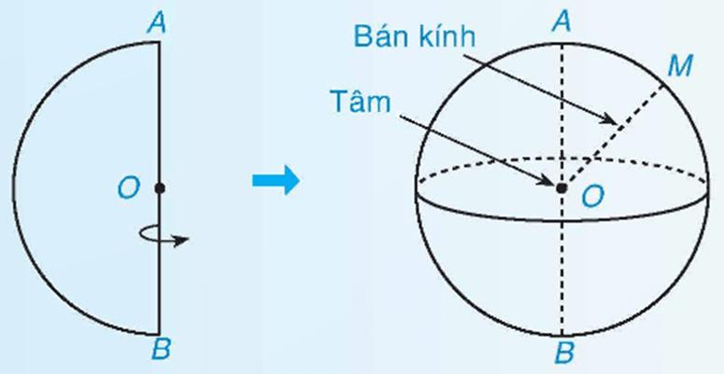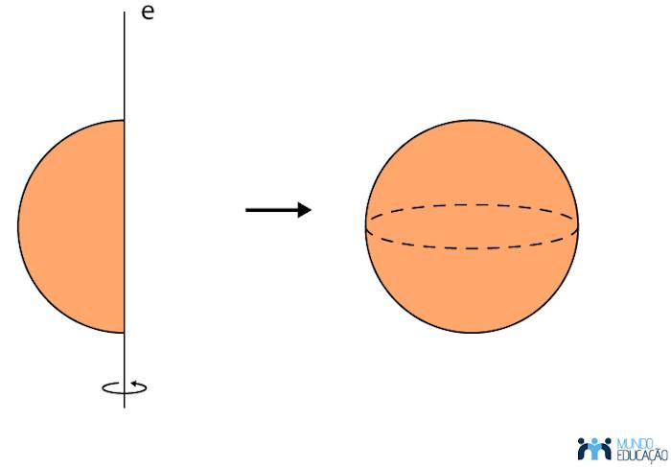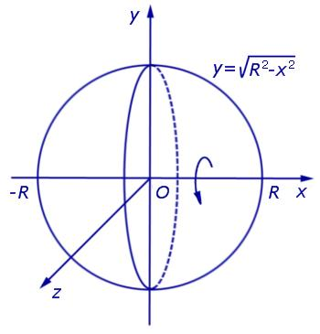
A Semicircular-Arc Generator is a curved-line generator consisting of half of a circle.
When it rotates around its diameter, it generates a complete spherical surface.
Characteristics:
- Its generating curve is a semicircular arc.
- Its diameter lies along the axis of revolution.
- Every point on the arc describes a circular path, except the endpoints, which remain on the axis.
- Its resulting surface is a sphere.

Elliptical-Curve Generator
# Source: AI Source: Provided by: [Data Path: Persons Table -> ID Column: 1, Name_En Column: Motasem Essam] -> From: [ChatGPT] on [7/25/2026]
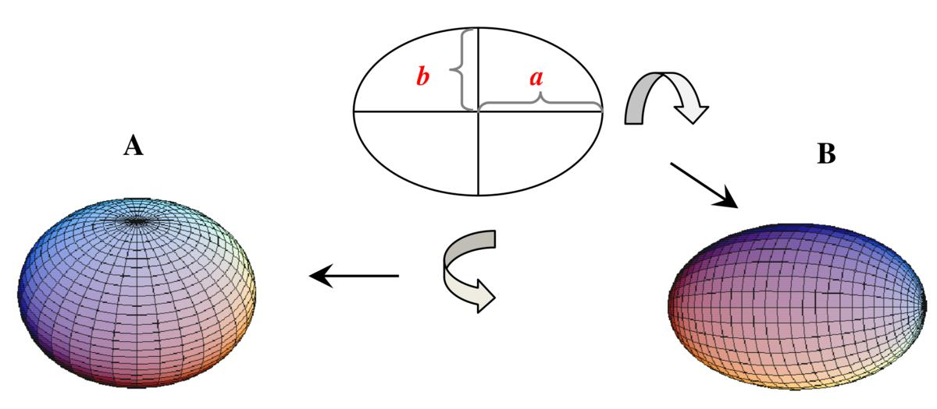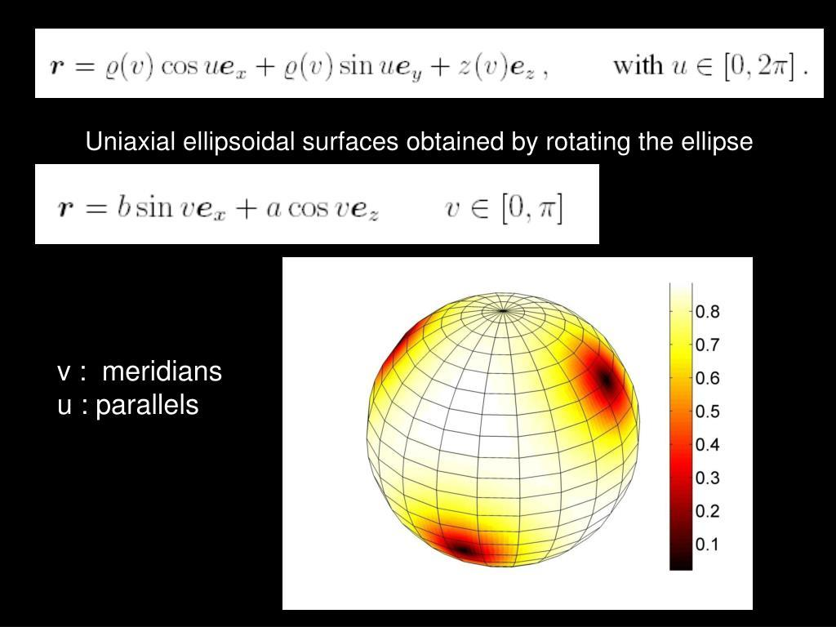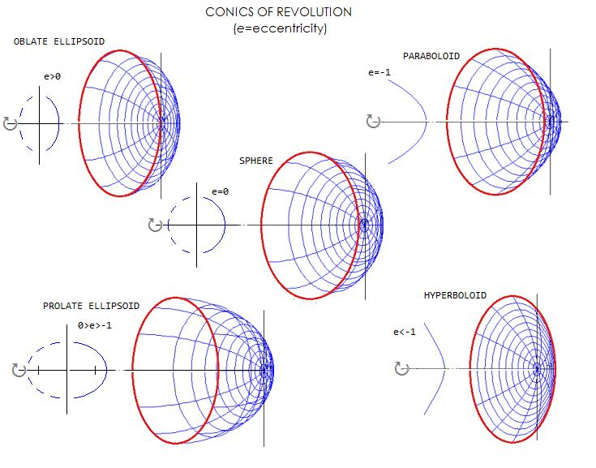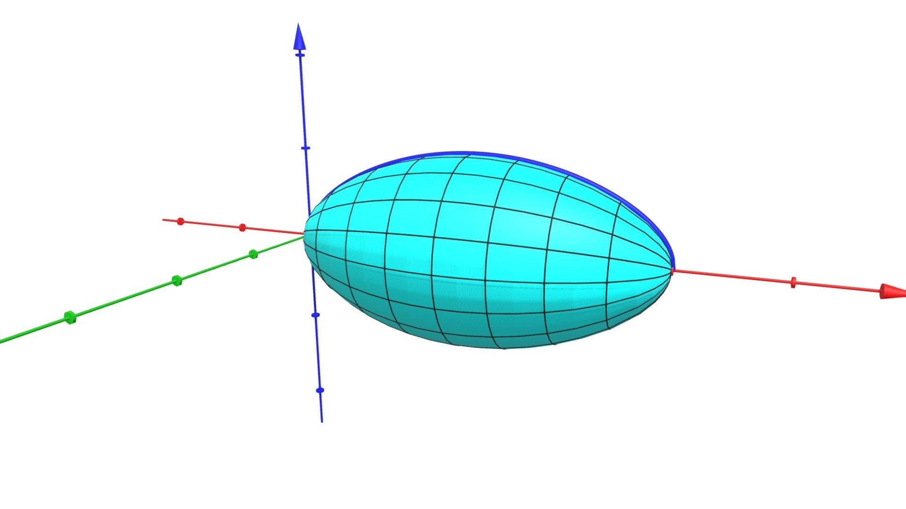
An Elliptical-Curve Generator is a curved-line generator whose shape is an ellipse.
When an ellipse rotates around one of its principal axes, it generates an ellipsoid of revolution, also called a spheroid.
Types:
- Prolate Spheroid Generator: An ellipse rotates around its major axis, producing an elongated spheroid.
- Oblate Spheroid Generator: An ellipse rotates around its minor axis, producing a flattened spheroid.

Parabolic-Curve Generator
# Source: AI Source: Provided by: [Data Path: Persons Table -> ID Column: 1, Name_En Column: Motasem Essam] -> From: [ChatGPT] on [7/25/2026]
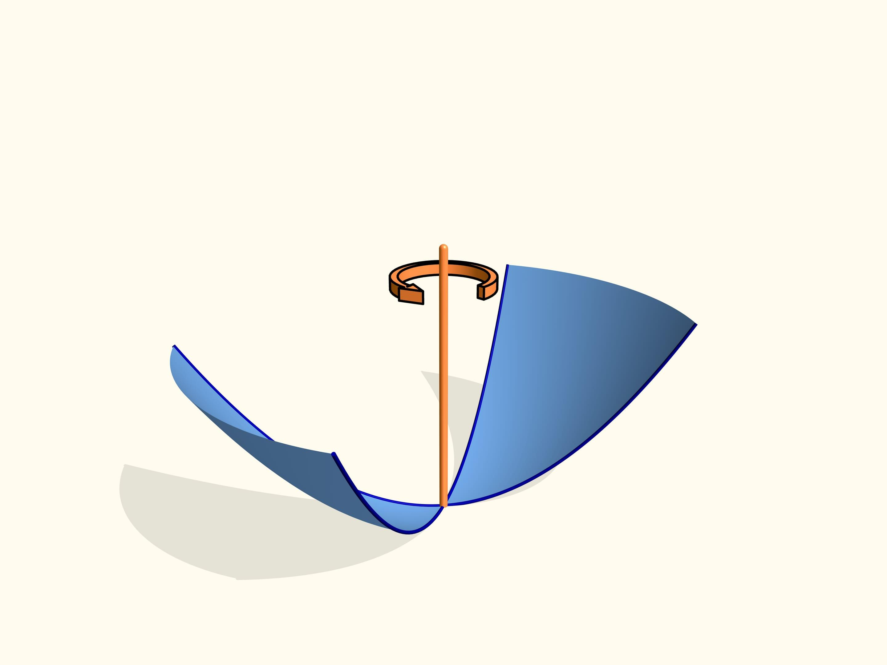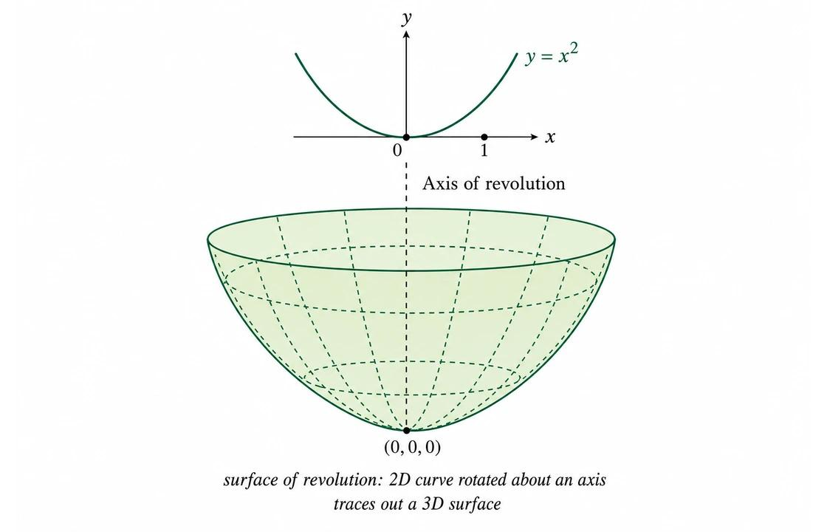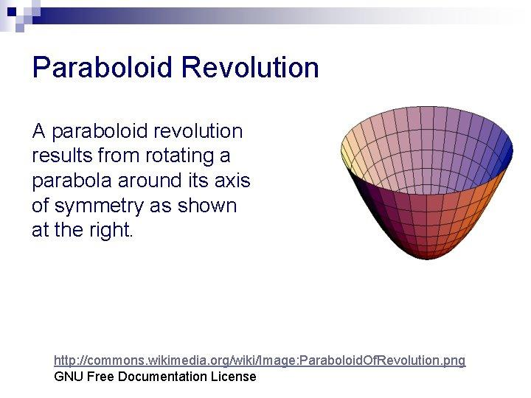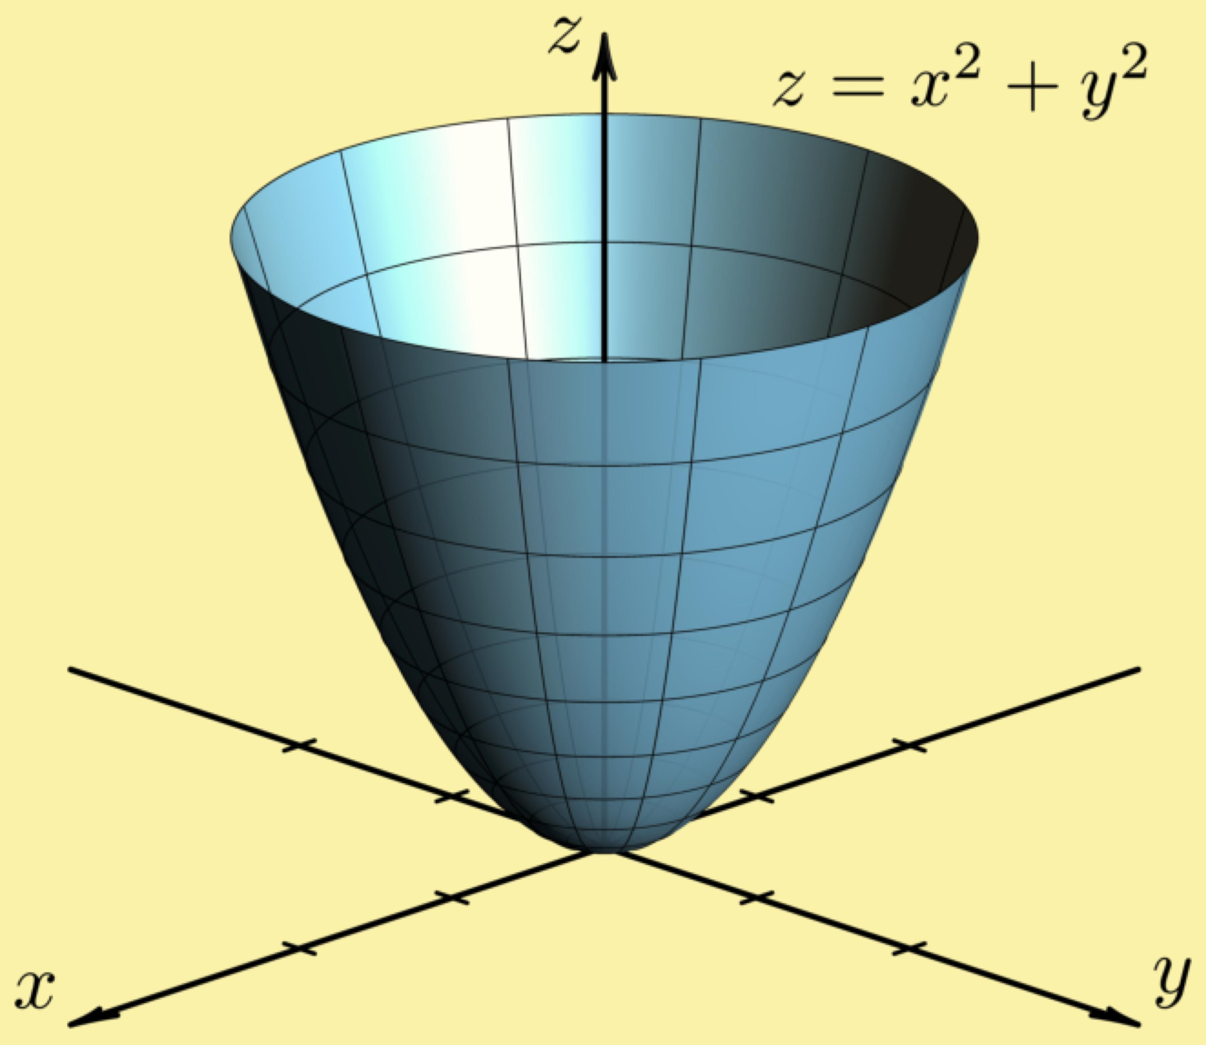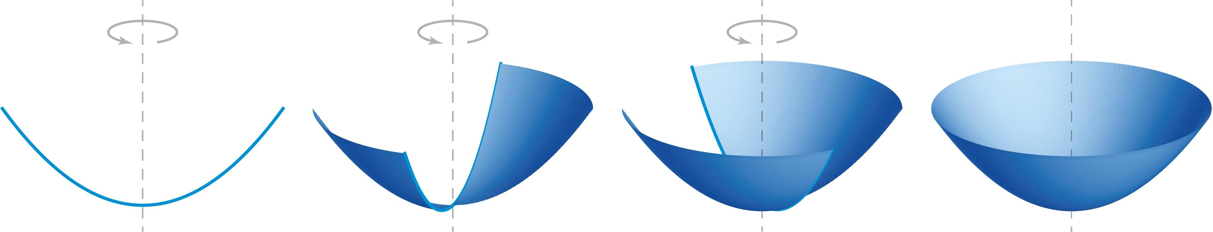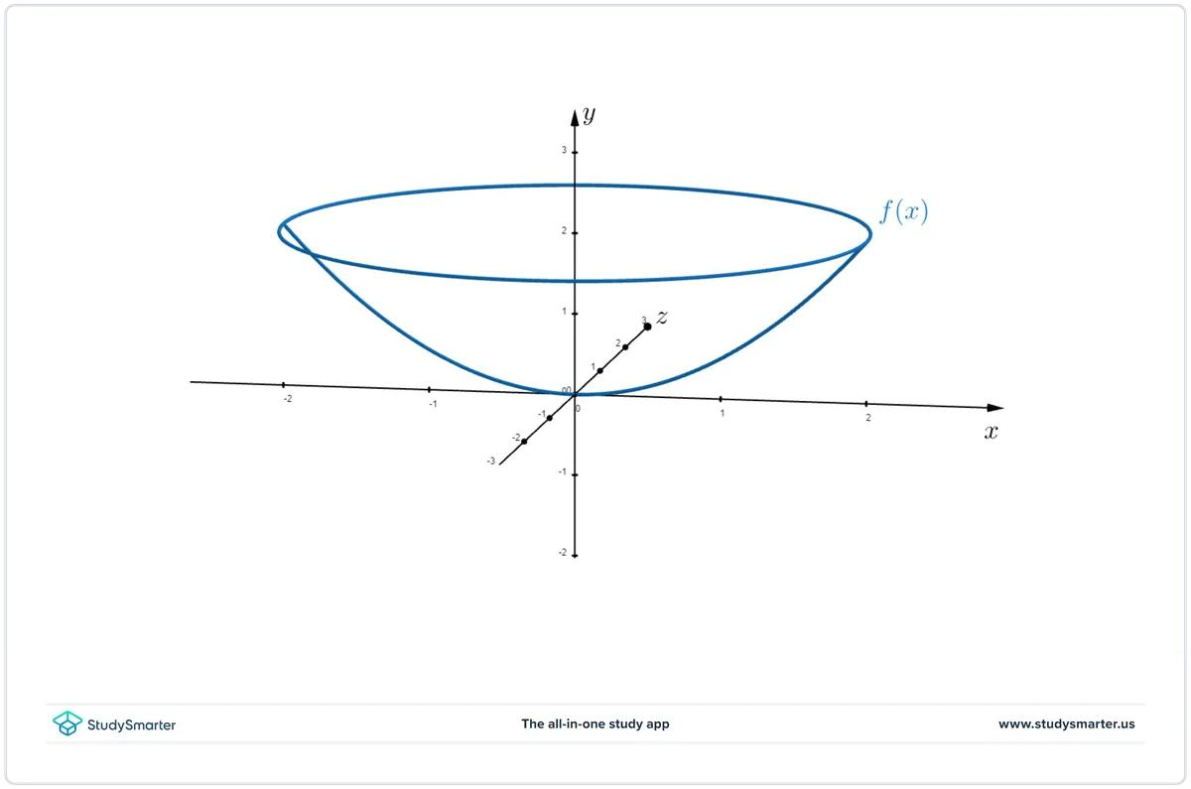
A Parabolic-Curve Generator is a curved-line generator whose shape is a parabola.
When a parabola rotates around its axis of symmetry, it generates a paraboloid of revolution.
Characteristics:
- The generating curve is parabolic.
- Its axis of symmetry coincides with the axis of revolution.
- Each point on the parabola describes a circular path around the axis.
- The resulting surface is a paraboloid of revolution.

Hyperbolic-Curve Generator
# Source: AI Source: Provided by: [Data Path: Persons Table -> ID Column: 1, Name_En Column: Motasem Essam] -> From: [ChatGPT] on [7/25/2026]
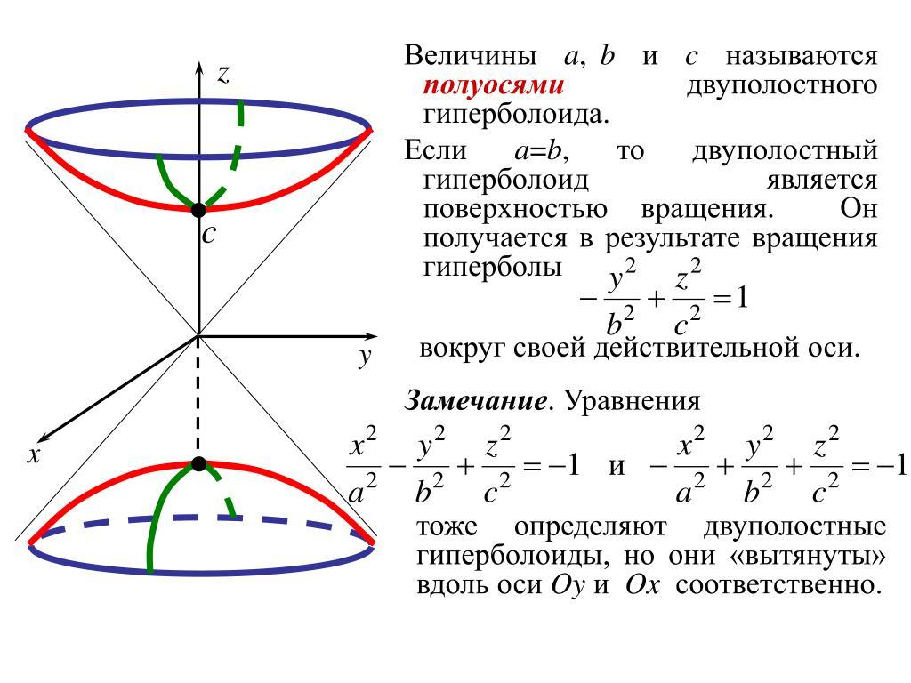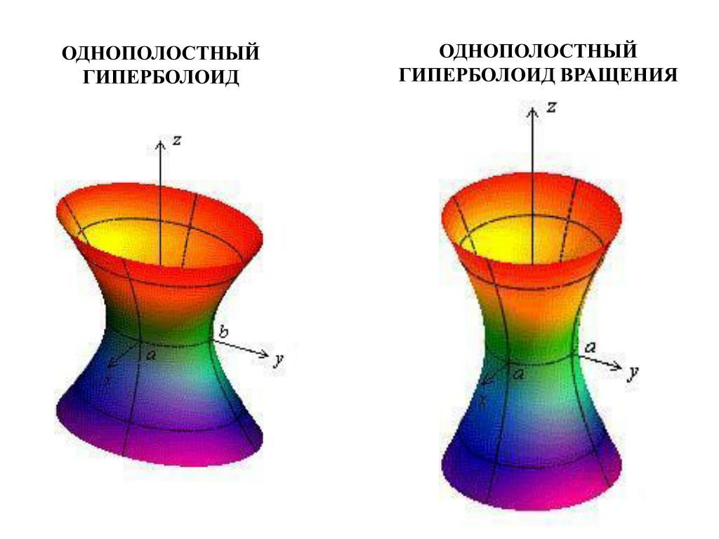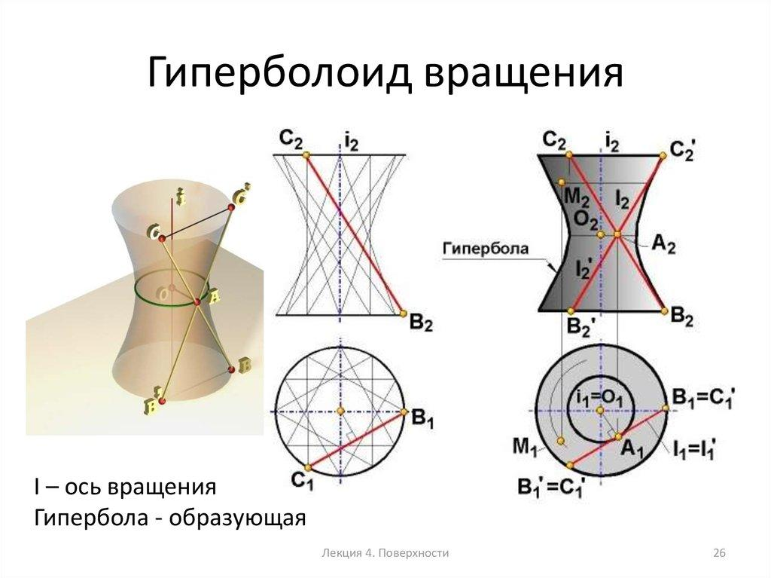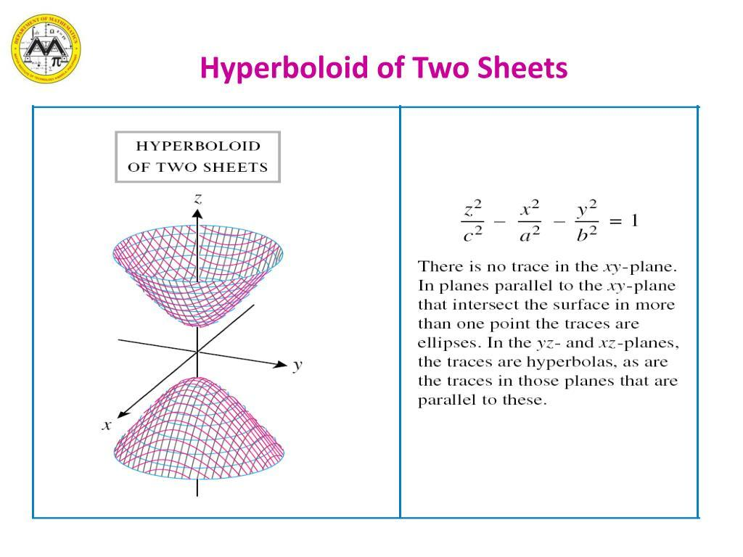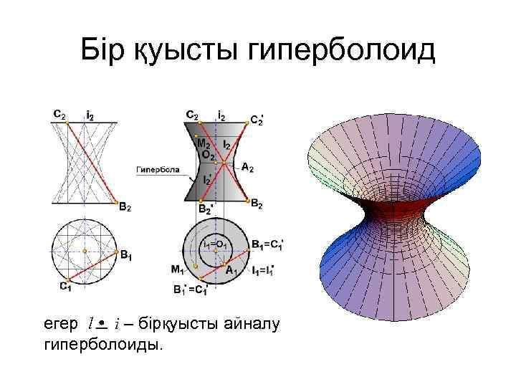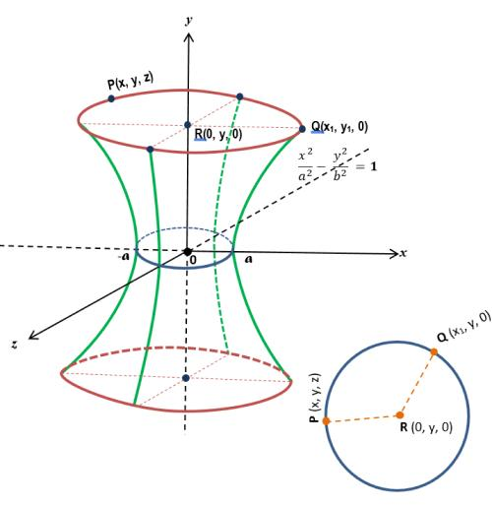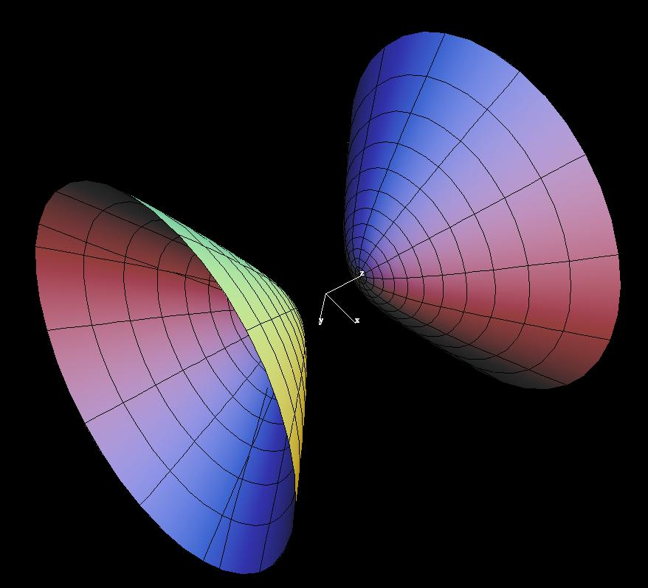
A Hyperbolic-Curve Generator is a curved-line generator whose shape is a hyperbola.
When a hyperbola rotates around one of its principal axes, it generates a hyperboloid of revolution.
Types:
- One-Sheet Hyperboloid Generator: A hyperbola rotates around its conjugate axis.
- Two-Sheet Hyperboloid Generator: A hyperbola rotates around its transverse axis.
The resulting surfaces have different geometric structures depending on the selected axis.

Mathematical Representation
# Source: AI Source: Provided by: [Data Path: Persons Table -> ID Column: 1, Name_En Column: Motasem Essam] -> From: [ChatGPT] on [7/25/2026]
A curved-line generator can be represented mathematically as a parametric curve that rotates around a fixed axis.

General Curved-Line Generator
# Source: AI Source: Provided by: [Data Path: Persons Table -> ID Column: 1, Name_En Column: Motasem Essam] -> From: [ChatGPT] on [7/25/2026]
Let the generating curve be represented by:
$$C(u)=beginpmatrixx(u)\backslash y(u)\backslash z(u)endpmatrix$$
Where $u$ is the curve parameter.
If the curve lies in the $xz$-plane and rotates around the $z$-axis, its generated surface is:
$$\boxed{beginalignedx(u,v)\&=r(u)cosv\backslash y(u,v)\&=r(u)sinv\backslash z(u,v)\&=z(u)endaligned}$$
Where:
- $r(u)$ = Distance of the generating curve from the axis.
- $z(u)$ = Height of the generating curve.
- $v$ = Rotation angle.
- $0≤v≤2π$ for a complete revolution.

Circular-Arc Generator
# Source: AI Source: Provided by: [Data Path: Persons Table -> ID Column: 1, Name_En Column: Motasem Essam] -> From: [ChatGPT] on [7/25/2026]
A circular generating curve can be represented by:
$$x^{2}+z^{2}=R^{2}$$
When rotated around its diameter (the $z$-axis), it generates a sphere:
$$\boxed{x^{2}+y^{2}+z^{2}=R^{2}}$$
Where $R$ is the sphere radius.

Elliptical-Curve Generator
# Source: AI Source: Provided by: [Data Path: Persons Table -> ID Column: 1, Name_En Column: Motasem Essam] -> From: [ChatGPT] on [7/25/2026]
An ellipse can be represented by:
$$\frac{x^{2}}{a^{2}}+\frac{z^{2}}{b^{2}}=1$$
When rotated around its major or minor axis, it generates an ellipsoid of revolution:
$$\boxed{\frac{x^{2}+y^{2}}{a^{2}}+\frac{z^{2}}{b^{2}}=1}$$

Parabolic-Curve Generator
# Source: AI Source: Provided by: [Data Path: Persons Table -> ID Column: 1, Name_En Column: Motasem Essam] -> From: [ChatGPT] on [7/25/2026]
A parabola can be represented by:
$$x^{2}=4pz$$
When rotated around its axis of symmetry, it generates a paraboloid of revolution:
$$\boxed{x^{2}+y^{2}=4pz}$$

Hyperbolic-Curve Generator
# Source: AI Source: Provided by: [Data Path: Persons Table -> ID Column: 1, Name_En Column: Motasem Essam] -> From: [ChatGPT] on [7/25/2026]
A hyperbola can be represented by:
$$\frac{x^{2}}{a^{2}}-\frac{z^{2}}{b^{2}}=1$$
When rotated around its conjugate axis, it generates a hyperboloid of one sheet:
$$\boxed{\frac{x^{2}+y^{2}}{a^{2}}-\frac{z^{2}}{b^{2}}=1}$$
Rotating the appropriate hyperbolic curve around its transverse axis generates a hyperboloid of two sheets.

Geometric Properties
# Source: AI Source: Provided by: [Data Path: Persons Table -> ID Column: 1, Name_En Column: Motasem Essam] -> From: [ChatGPT] on [7/25/2026]
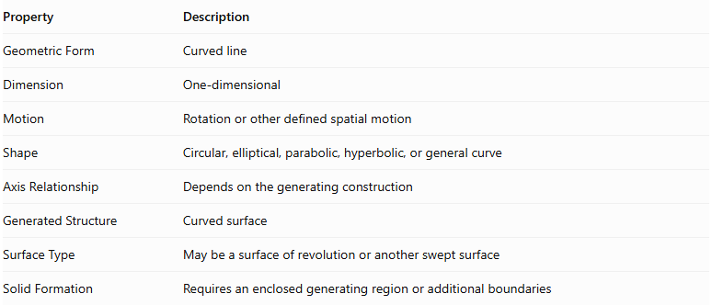
Property | Description
Geometric Form | Curved line
Dimension | One-dimensional
Motion | Rotation or other defined spatial motion
Shape | Circular, elliptical, parabolic, hyperbolic, or general curve
Axis Relationship | Depends on the generating construction
Generated Structure | Curved surface
Surface Type | May be a surface of revolution or another swept surface
Solid Formation | Requires an enclosed generating region or additional boundaries

Comparison of Curved-Line Generator Types
# Source: AI Source: Provided by: [Data Path: Persons Table -> ID Column: 1, Name_En Column: Motasem Essam] -> From: [ChatGPT] on [7/25/2026]
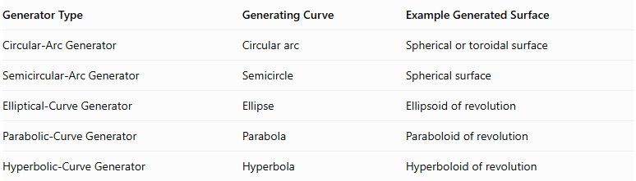
Generator Type | Generating Curve | Example Generated Surface
Circular-Arc Generator | Circular arc | Spherical or toroidal surface
Semicircular-Arc Generator | Semicircle | Spherical surface
Elliptical-Curve Generator | Ellipse | Ellipsoid of revolution
Parabolic-Curve Generator | Parabola | Paraboloid of revolution
Hyperbolic-Curve Generator | Hyperbola | Hyperboloid of revolution

Curved-Line Generator vs. Straight-Line Generator
# Source: AI Source: Provided by: [Data Path: Persons Table -> ID Column: 1, Name_En Column: Motasem Essam] -> From: [ChatGPT] on [7/25/2026]
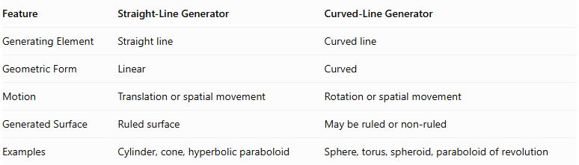
Feature | Straight-Line Generator | Curved-Line Generator
Generating Element | Straight line | Curved line
Geometric Form | Linear | Curved
Motion | Translation or spatial movement | Rotation or spatial movement
Generated Surface | Ruled surface | May be ruled or non-ruled
Examples | Cylinder, cone, hyperbolic paraboloid | Sphere, torus, spheroid, paraboloid of revolution

Important Distinctions
# Source: AI Source: Provided by: [Data Path: Persons Table -> ID Column: 1, Name_En Column: Motasem Essam] -> From: [ChatGPT] on [7/25/2026]
- Curved-Line Generator vs. Plane-Region Generator: A curved-line generator produces a surface, whereas a plane-region generator can produce a three-dimensional solid when it moves through space.
- Generating Curve vs. Generated Surface: The generating curve is the original one-dimensional element; the generated surface is the resulting two-dimensional surface.
- Surface of Revolution: This is a particular type of surface produced by rotating a curve around a fixed axis.
- Circular Arc vs. Semicircular Arc: A semicircular arc is a specific type of circular arc, not an entirely separate fundamental curve family.
- Curved Generator vs. Curved Solid: The generator itself is not the solid; additional boundaries or a generating region are needed to define a solid.

Main Classification
# Source: AI Source: Provided by: [Data Path: Persons Table -> ID Column: 1, Name_En Column: Motasem Essam] -> From: [ChatGPT] on [7/25/2026]
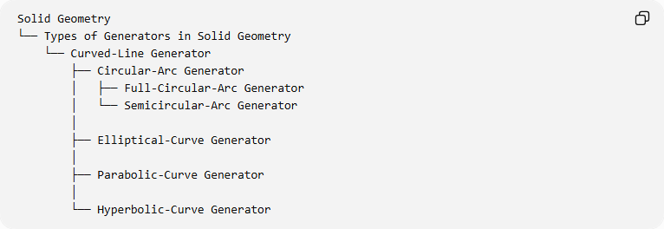
Solid Geometry
└── Types of Generators in Solid Geometry
└── Curved-Line Generator
├── Circular-Arc Generator
│ ├── Full-Circular-Arc Generator
│ └── Semicircular-Arc Generator
│
├── Elliptical-Curve Generator
│
├── Parabolic-Curve Generator
│
└── Hyperbolic-Curve Generator
Classification note: These are common generating-curve families, not an exhaustive mathematical classification. General curved-line generators can also use other curves, such as catenaries, cycloids, and spline curves.

Key Points
# Source: AI Source: Provided by: [Data Path: Persons Table -> ID Column: 1, Name_En Column: Motasem Essam] -> From: [ChatGPT] on [7/25/2026]
- A curved-line generator is a curved geometric element used to generate a surface.
- It can be a circular arc, semicircle, ellipse, parabola, hyperbola, or another curve.
- Rotating a semicircular arc around its diameter generates a sphere.
- Rotating an ellipse around a principal axis generates a spheroid.
- Rotating a parabola around its axis generates a paraboloid of revolution.
- Rotating a hyperbola around an appropriate principal axis generates a hyperboloid of revolution.
- A curved-line generator is different from a plane-region generator, which can generate a solid.

Conclusion
# Source: AI Source: Provided by: [Data Path: Persons Table -> ID Column: 1, Name_En Column: Motasem Essam] -> From: [ChatGPT] on [7/25/2026]
The Curved-Line Generator is an important generating element in solid geometry. It uses curved geometric elements to produce surfaces through rotation or other spatial motion. Its different forms provide the geometric foundation for generating spheres, tori, spheroids, paraboloids, hyperboloids, and many other curved surfaces.
References:
- Generating Surfaces – Differential Geometry
- Surfaces of Revolution – Descriptive Geometry
- MathCurve – Surfaces of Revolution

